**11- Error Handling**

Write a Python program that asks the user for their age and prints a message based on the age. Ensure that the program handles cases where the input is not a valid integer.

**Input Format:** A single line input representing the user's age.

**Output Format:** Print a message based on the age or an error if the input is invalid.

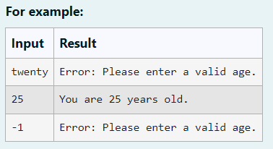

**Program:**

def get_age():

try:

age=int(input())

if age<0:

print("Error: Please enter a valid age.")

else:

print(f"You are {age} years old.")

except :

print("Error: Please enter a valid age.")

get_age()

Develop a Python program that safely performs division between two numbers provided by the user. Handle exceptions like division by zero and non-numeric inputs.

**Input Format:** Two lines of input, each containing a number.

**Output Format:** Print the result of the division or an error message if an exception occurs.

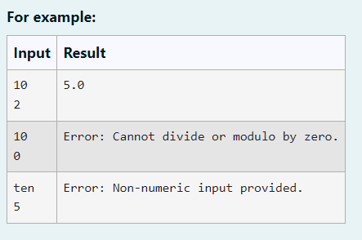

**Program:**

**try:**

**num1=float(input())**

**num2=float(input())**

**result=num1/num2**

**print(result)**

**except ZeroDivisionError:**

**print("Error: Cannot divide or modulo by zero.")**

**except ValueError:**

**print("Error: Non-numeric input provided.")**

Problem Description:

Develop a Python program that safely calculates the square root of a number provided by the user. Handle exceptions for negative inputs and non-numeric inputs.

Input Format:

User inputs a number.

Output Format:

Print the square root of the number or an error message if an exception occurs.

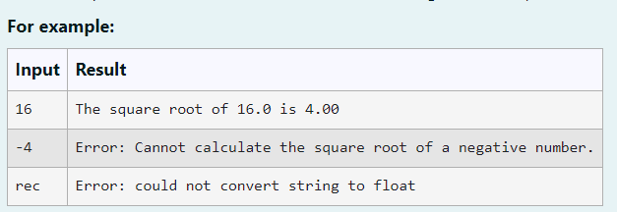

**Program:**

try:

num = float(input())

if num >= 0:

print(f"The square root of {num} is {num**.5:.2f}")

else:

print("Error: Cannot calculate the square root of a negative number.")

except ValueError:

print("Error: could not convert string to float")

Write a Python program that performs division and modulo operations on two numbers provided by the user. Handle division by zero and non-numeric inputs.

Input Format:

Two lines of input, each containing a number.

Output Format:

Print the result of division and modulo operation, or an error message if an exception occurs.

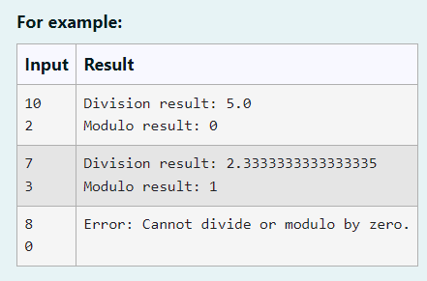

**Program:**

try:

a=int(input())

b=int(input())

print("Division result:",a/b)

print("Modulo result:",a%b)

except ZeroDivisionError:

print("Error: Cannot divide or modulo by zero.")

except ValueError:

print("Error: Non-numeric input provided.")

Problem Description:

Write a Python script that asks the user to enter a number within a specified range (e.g., 1 to 100). Handle exceptions for invalid inputs and out-of-range numbers.

Input Format:

User inputs a number.

Output Format:

Confirm the input or print an error message if it's invalid or out of range.

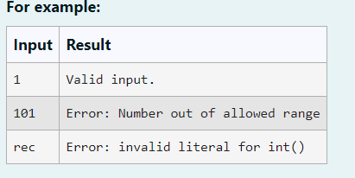

**Program:**

try:

a=int(input())

if (a<0):

print("Error: Number out of allowed range")

elif (a>=1 and a<=100):

print("Valid input.")

else:

print("Error: Number out of allowed range")

except:

print("Error: invalid literal for int()")